- 需求
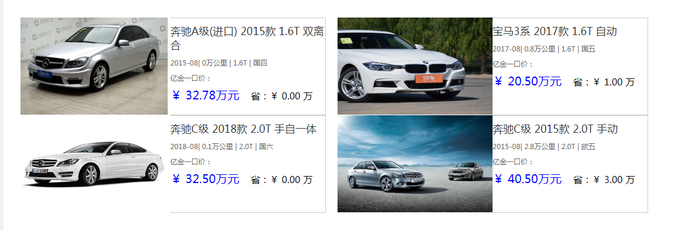
- 需求的实现

- 后台
#处理查询汽车功能
def getallcars(request):
response = {}
car_dict={}
carslists=[]
try:
cars = CarDetail.objects.filter()
print(cars)
for car in cars:
car_dict['eps']=car.eps.eps_name
car_dict['car_year']=car.car_year
car_dict['license_time']=car.license_time
car_dict['distance']=car.distance
car_dict['sale_price']=car.sale_price
car_dict['concessional_price']=car.concessional_price
car_dict['img']=car.img
car_dict['carid']=car.car_id
car_dict['brand']=car.brand.brand_name
car_dict['engine_type']=car.engine_type.engine_type_name
car_dict['transmissio_type']=car.transmissio_type.transmissio_name
carslists.append(car_dict)
car_dict={}
#response['list'] = json.loads(serializers.serialize("json", cars), encoding="GB2312")
response['list']=carslists
response['msg'] = 'success'
response['error_num'] = 0
except Exception as e:
response['msg'] = str(e)
response['error_num'] = 1
return JsonResponse(response)

- 前端
data: {

carslists: [],
}
mounted: function() {
axios({
method: 'get',
url: "http://localhost:8000/api/getall",

}).then(function(resp) {

v1.carslists = resp.data['list'];
})

},

<div v-for="car in carslists" >
<p style="height:20px;" ></p>
<section style="padding-left:30px;">
<img v-bind:src="car.img"/>
</section>
<section style="border-top:1px solid #ccc;border-right:1px solid #ccc;border-bottom:1px solid #ccc;">
<p style="font-size:18px;color:#333;padding-top:10px;">{{car.brand}} {{car.car_year}} {{car.engine_type}} {{car.transmissio_type}}<br/></p>
<p style="padding-top:10px;padding-bottom: 10px;">{{car.license_time}}| {{car.distance}}万公里 | {{car.engine_type}} | {{car.eps}}</p>

<p>亿金一口价：<br/>
<p style="height:8px;"></p>
<span style="font-size:20px;color:blue;">￥ {{car.sale_price}}万元 </span>&nbsp;&nbsp;&nbsp;省：￥ {{car.concessional_price}} 万
</p>

</section>
</div>

